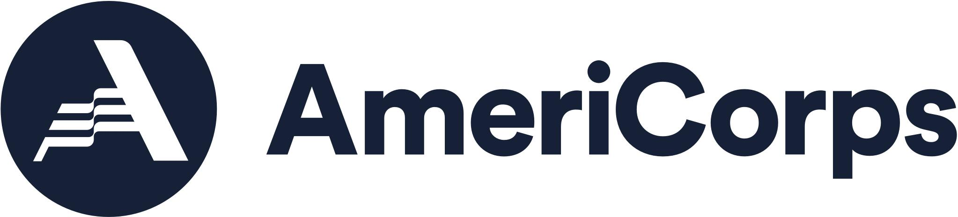

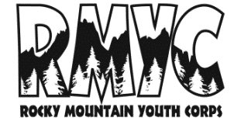
ROCKY MOUNTAIN YOUTH CORPS
2023 Recreation Intern

Partner Agency: Bureau of Land Management- Colorado River Valley Field Office
Positions Available: 2
Location: Silt, CO
Tentative Dates: April 8 - September 7, 2023 (or upon completion of 22 weeks).
Stipend: $750/week living allowance. Total amount will be $16,500.
AmeriCorps: 900-hour AmeriCorps Education Award ($3,447.50) upon successful completion
Plus: Boot/gear reimbursement up to $400
Public Land Corps Hiring Authority upon completion of 640 hours on public lands.
Program Overview:
Interns will serve with experienced BLM crew leads and specialists to manage recreation areas.
- Perform facility maintenance at developed recreation sites including cleaning vault toilets, cleaning campsite fire pits, collecting trash and fixing structures such as signs, kiosks and picnic tables.
- Installs and maintains various types of signage on public lands including informational signs at developed campsites, off-road vehicle, wilderness, portal, boundary, directional road and trail, and interpretive signing.
- Collect visitor use surveys using a tablet and the Survey123 program.
- Collect visitor use data by installing and operating traffic counters at developed recreation sites.
- Assist in the monitoring of Special Recreation Permits through submitting visitor use surveys at developed recreation sites and dispersed BLM lands.
- Greets visitors and provides information and education concerning use of public lands.
- Monitor road/trail conditions and perform trail maintenance.
- Inspects facilities ensuring compliance with rules and regulations pertaining to parking, campfires, sanitation, and safety; bringing problems or violations to the attention of visitors and/or reports potential violations to Recreation Planners.
- Additional opportunities may be available for interns to help with other BLM staff given interest expressed by intern and current BLM field office needs.
- Service will be completed in remote areas on BLM lands. Interns will be required to drive long distances, often on rough roads, in the field office.
- Crews will often serve a four-day week for ten hours a day. Interns will be trained to operate 4x4 pickups and utility terrain vehicles.
General Qualifications:
- This is primarily a field position, and interns will serve in remote areas, sometimes during adverse weather conditions including extreme heat, monsoonal rains, snow. Some hiking will be required.
- Skilled at communicating and staying calm during tedious tasks while working in challenging environments.
- Ability to maintain a close working relationship with crew members.
- Comfortable with driving trucks on 4WD roads in unpredictable conditions. Some experience with UTVs and small engines helpful.
- Must possess a valid driver’s license to operate government vehicles and equipment.

Service Statement:
As an AmeriCorps service program, RMYC holds all of its staff to the highest standards of service focused on environmental stewardship, education, and healthy futures. AmeriCorps is a federal program that is a network of local, state, and national service programs that connect over 70,000 Americans each year in intensive service to meet community needs. Their mission is to strengthen communities and develop leaders through direct and team-based national and community service. We provide resources and people power to organizations dedicated to the improvement of communities. We enrich the lives of those we serve and those who serve. Participants grow personally and professionally gaining new skill sets through providing hands-on work experience, valuable networking opportunities, and professional skills training. Why do you want to serve with AmeriCorps? Spending a season serving with AmeriCorps through RMYC can be a life-changing and rewarding experience. Successful candidates will demonstrate a commitment to service, diversity, self-development, and the team environment.

Requirements:
- High School Diploma or equivalent
- 18 Years of age or older with a valid driver license and clean driving record.
- Eligibility to work in the US
- This position is supported by the Public Lands Hiring Authority which requires candidates to be
between the ages of 16 to 30.
- Pre-service background screening required, including FBI background check
- Must be able to provide proof of eligibility to work in the United States

CONDITIONS OF AGREEMENT: AmeriCorps members will be subject to all state and federal laws, and the rules and regulations of OSHA and RMYC. The member is expected to fully understand and adhere to the rules, regulations and code of conduct as described in the AmeriCorps member manual. 10/19 Policy violations will result in disciplinary action according to program guidelines, including written warnings, fines, suspension without stipend, and/or termination. The AmeriCorps member is accountable for meeting or exceeding the responsibilities of this position as described above, and will be evaluated at mid-term and end-term by Corps Program Staff, with input from project hosts. Successful completion is contingent on both AmeriCorps education award hours and service through the agreed upon term end date.
This position is classified as Temporary Exempt and is a seasonal position with no benefits.
Rocky Mountain Youth Corps is an Equal Opportunity Employer. Rocky Mountain Youth Corps is committed to the inclusion of members with all levels of ability. Reasonable accommodations are available upon request. This program is available to all, without regard age 40 and over, color, disability, gender identity, genetic information, military or veteran status, national origin, race, religion, sex, sexual orientation or any other applicable status protected by state or local law.
991 Captain Jack Dr. Steamboat Springs, CO 80487 (970) 879-2135 www.rockymountainyouthcorps.org

___________________________________________________________________________________________Member Name Signature Date

